By Ishan Sharma

MIS/BUAN 6346 - BIG DATA ANALYTICS

AWS EMR SETUP

 

**Contents**

**Making a Key Pair 2**

**Making an AWS ROLE 3**

**Provition an EMR Cluster 11**

**Steps to modify the security group: 17**

**Setup the terminal MobaXterm 20**

# Making a Key Pair

Aws console- Select the region as N.Vergina

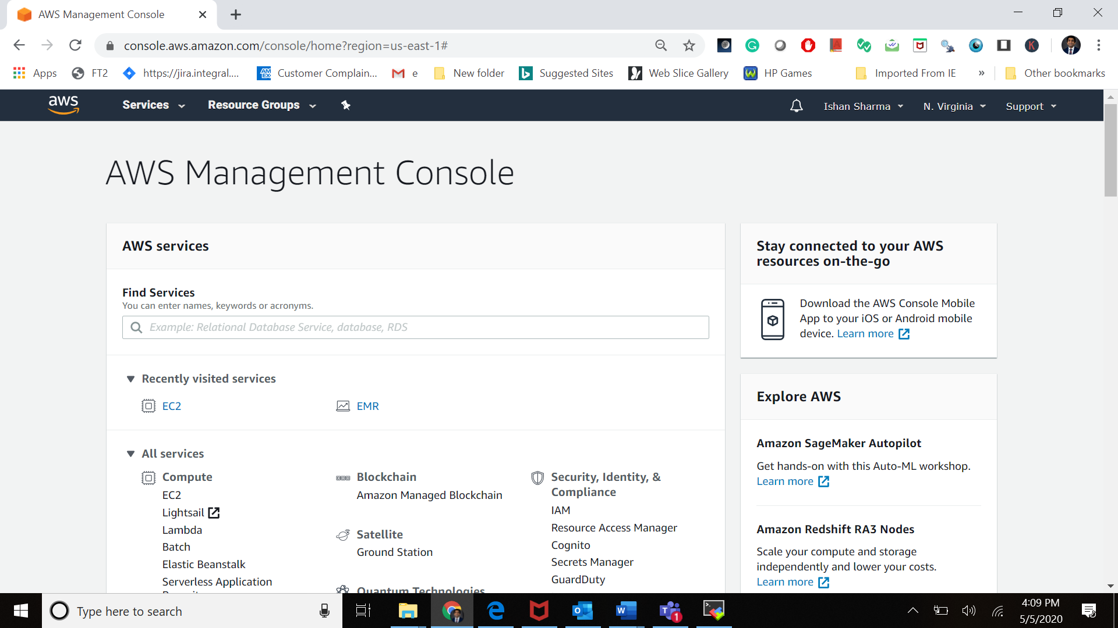

Click on the launch button to generate a new key pair.

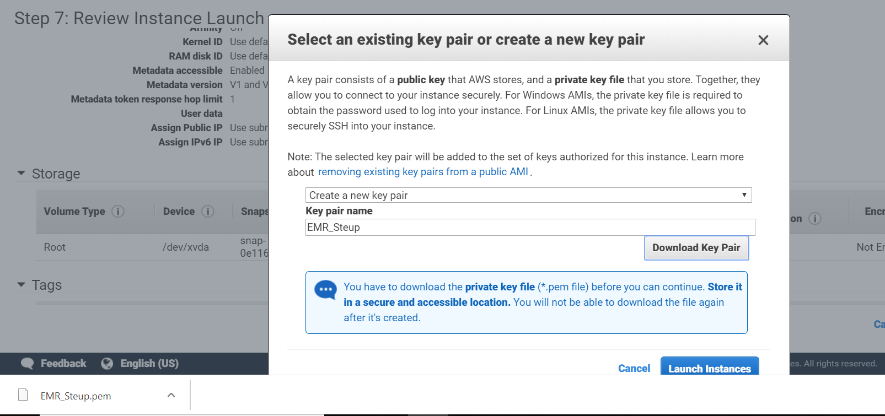

# Making an AWS ROLE

Make EMR_DefaultRole IAM role (In AWS you create Roles and then assign them to AWS resources)

To provision the EMR cluster we need to have the following policies to the EMR_DefaultRole

1. AmazonElasticMapReduceFullAccess
2. AmazonElasticMapReduceforEC2Role

Follow the following steps

Step1- Go the AWS console and search IAM

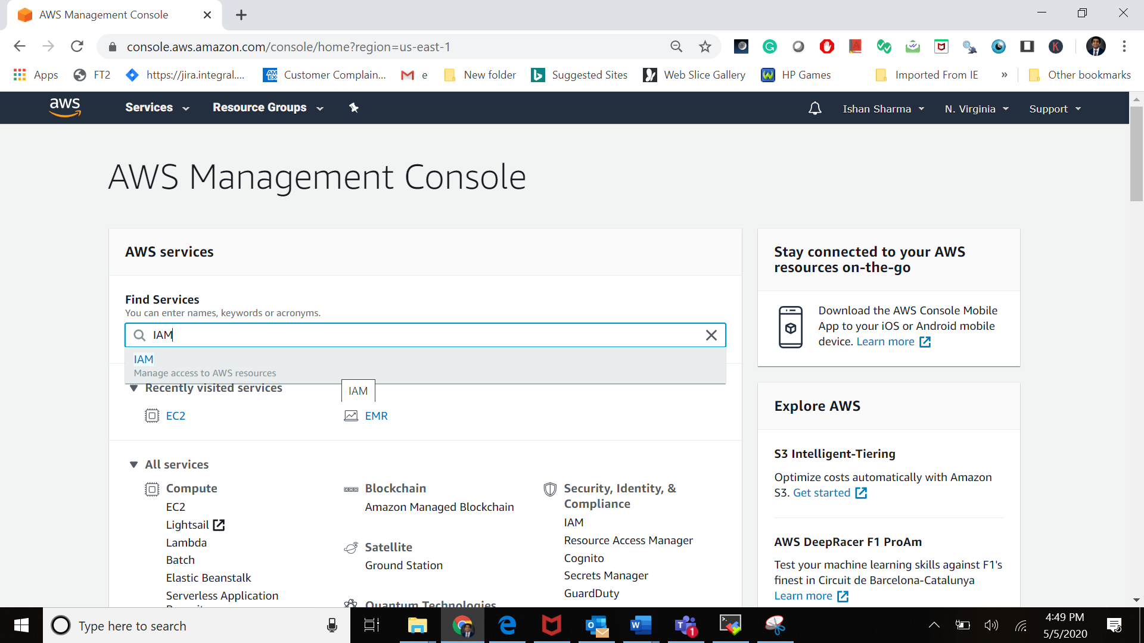

Click on the roles

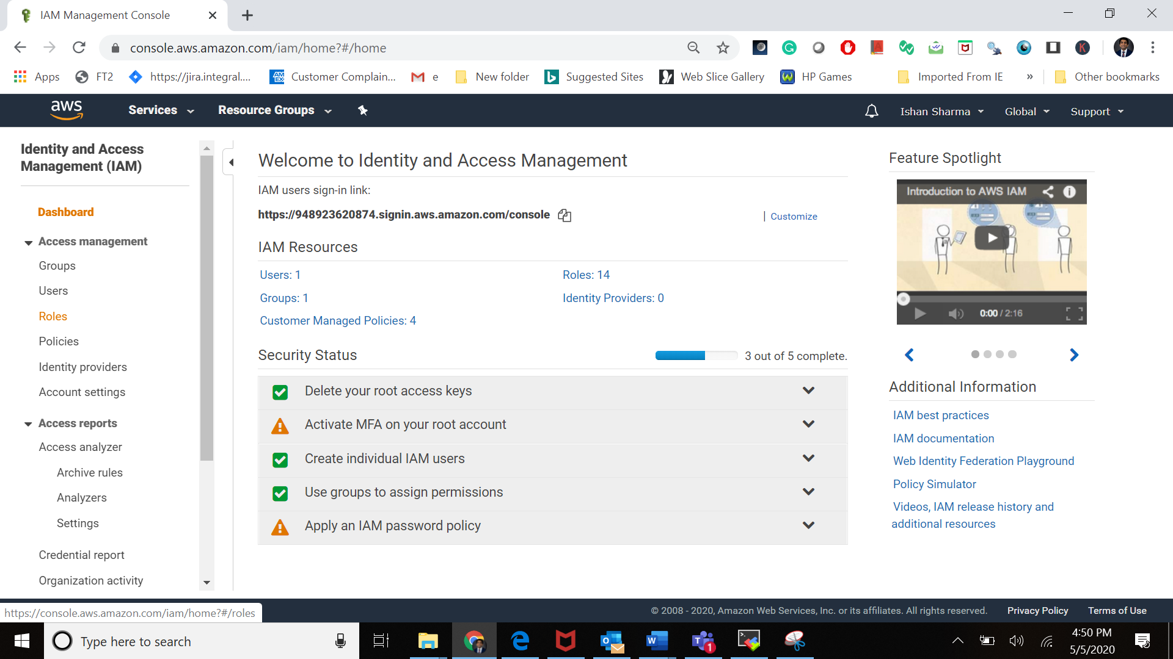

Click on Create roles

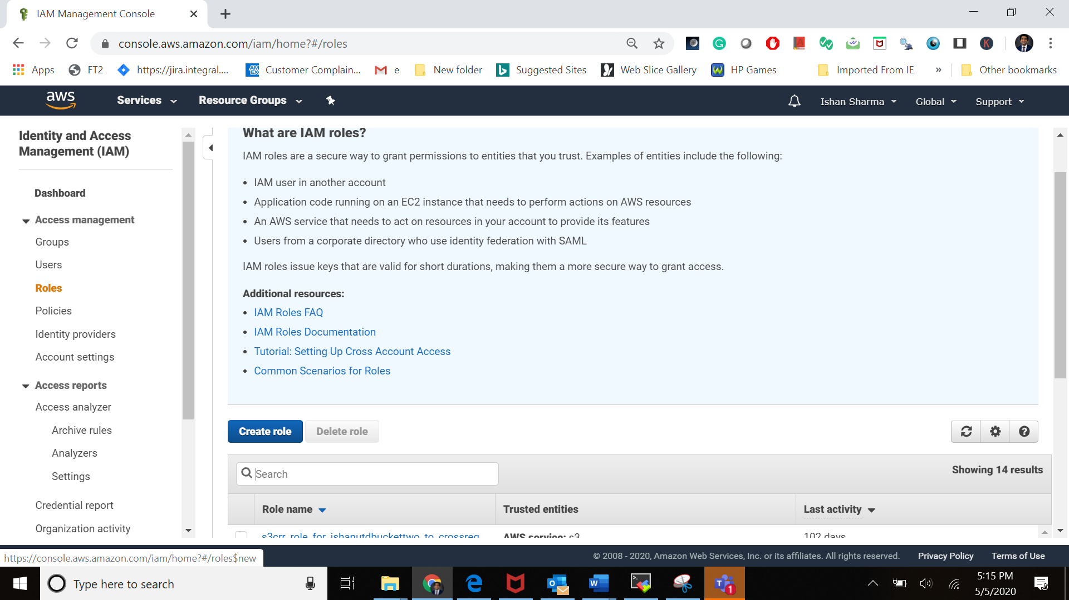

Select the use case

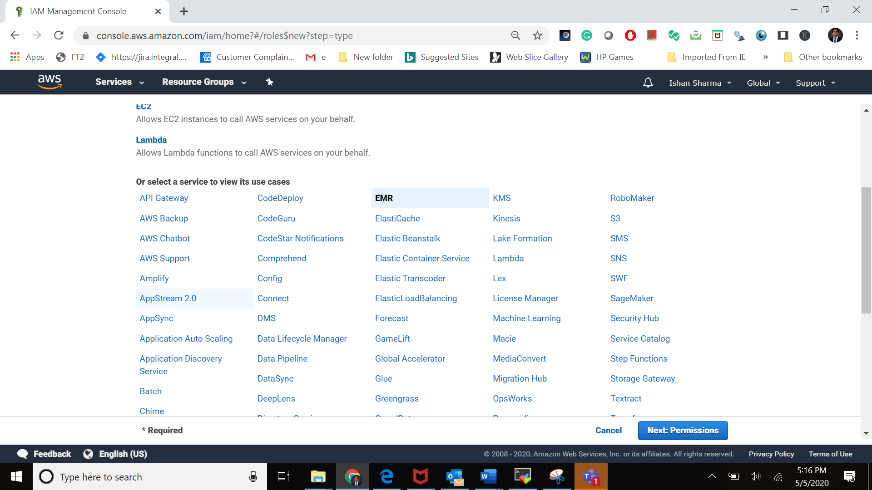

Now search the polices mentioned above.

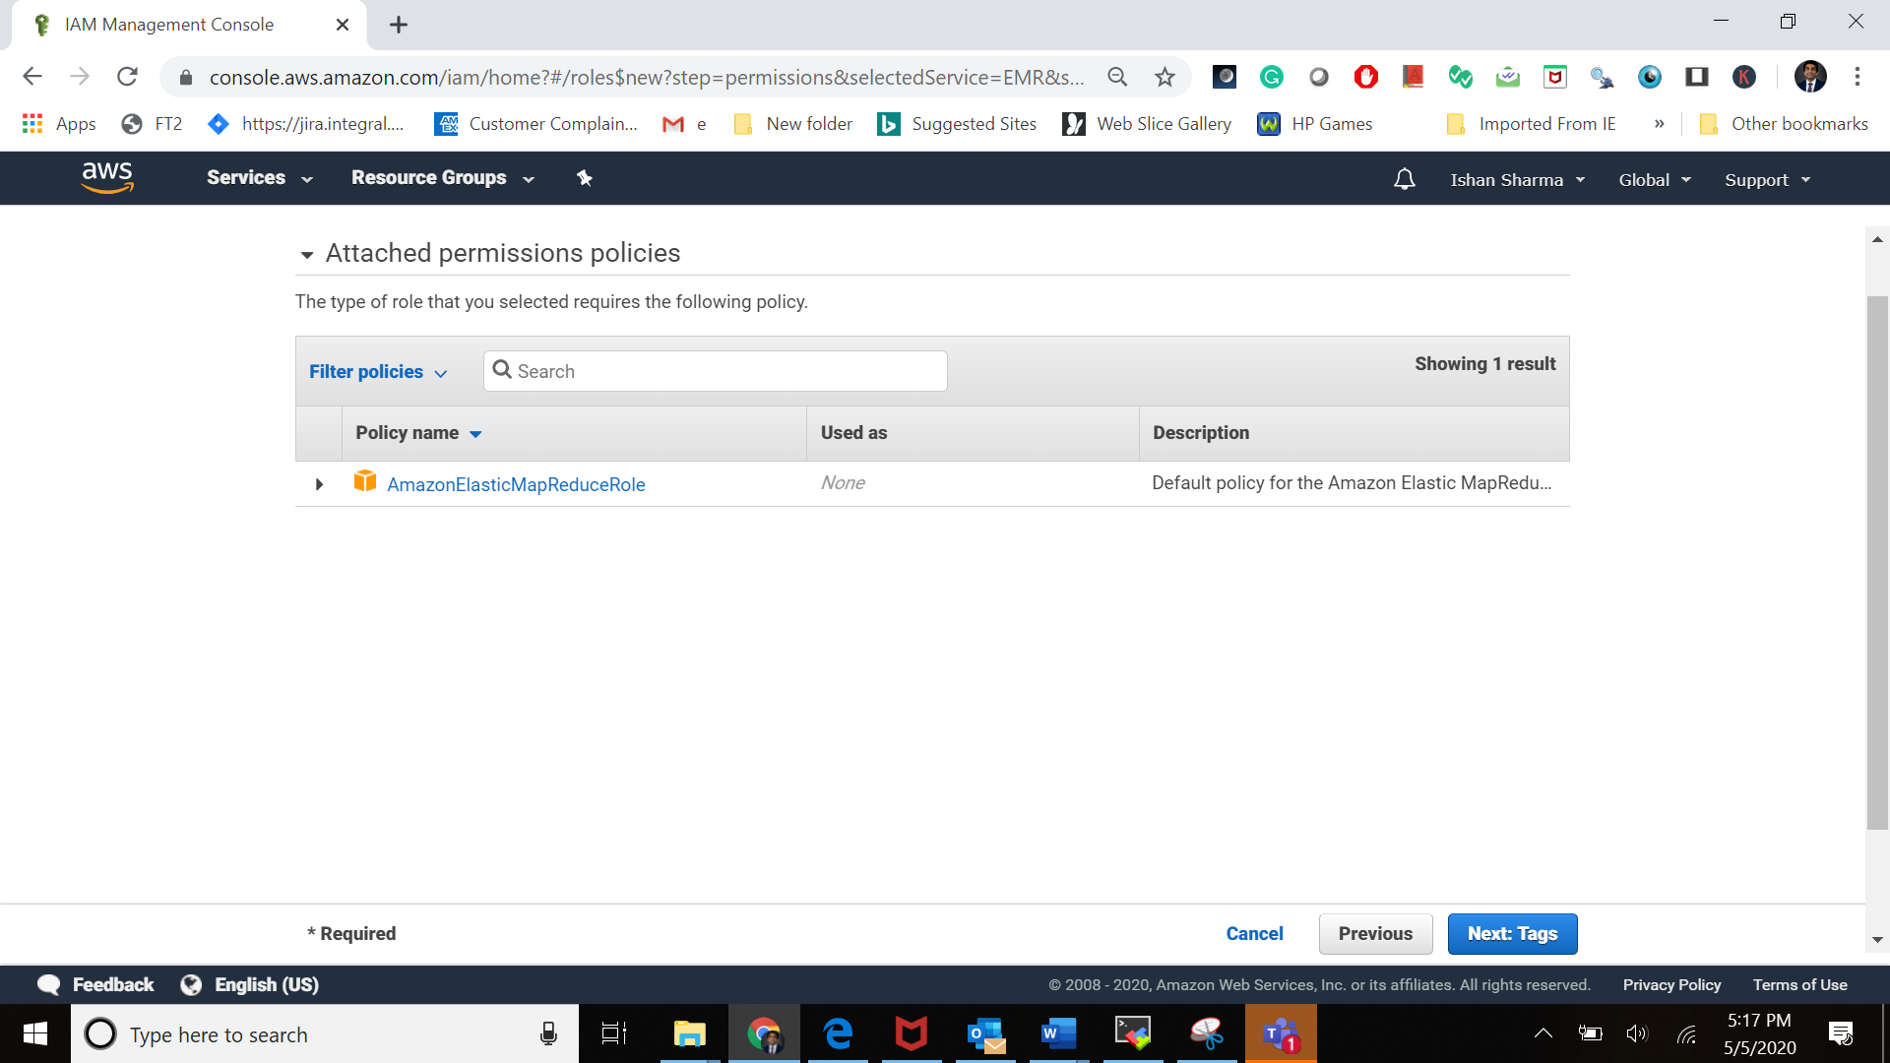

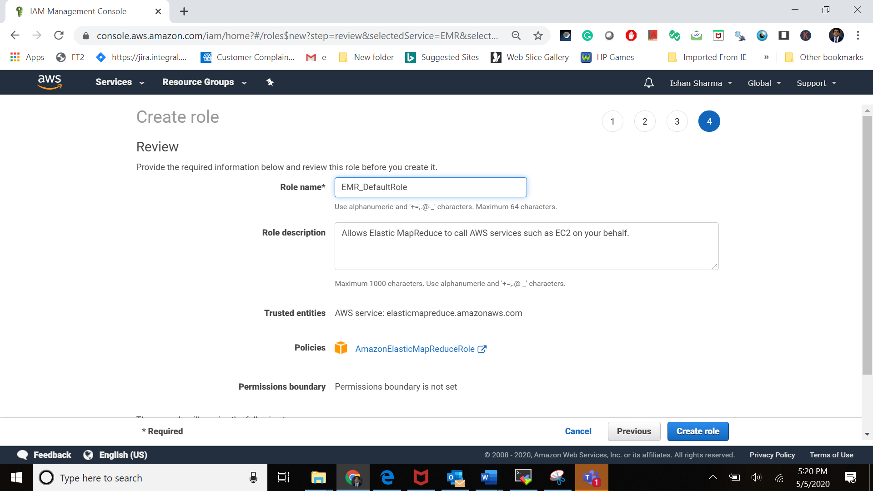

Now search the EMR_DefaultRole just created above:

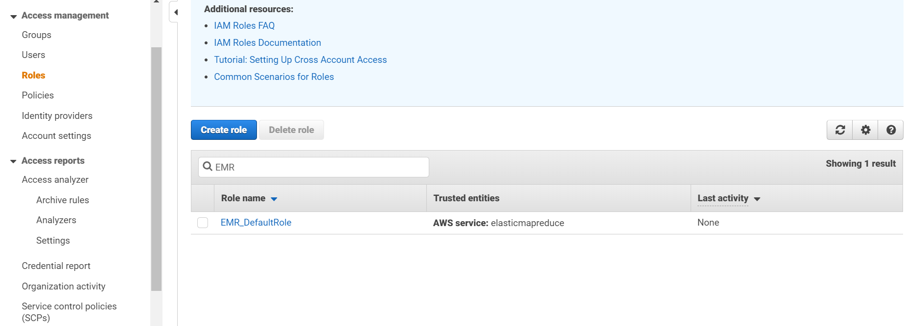

Click on the EMR_DefaultRole name to see the following screen

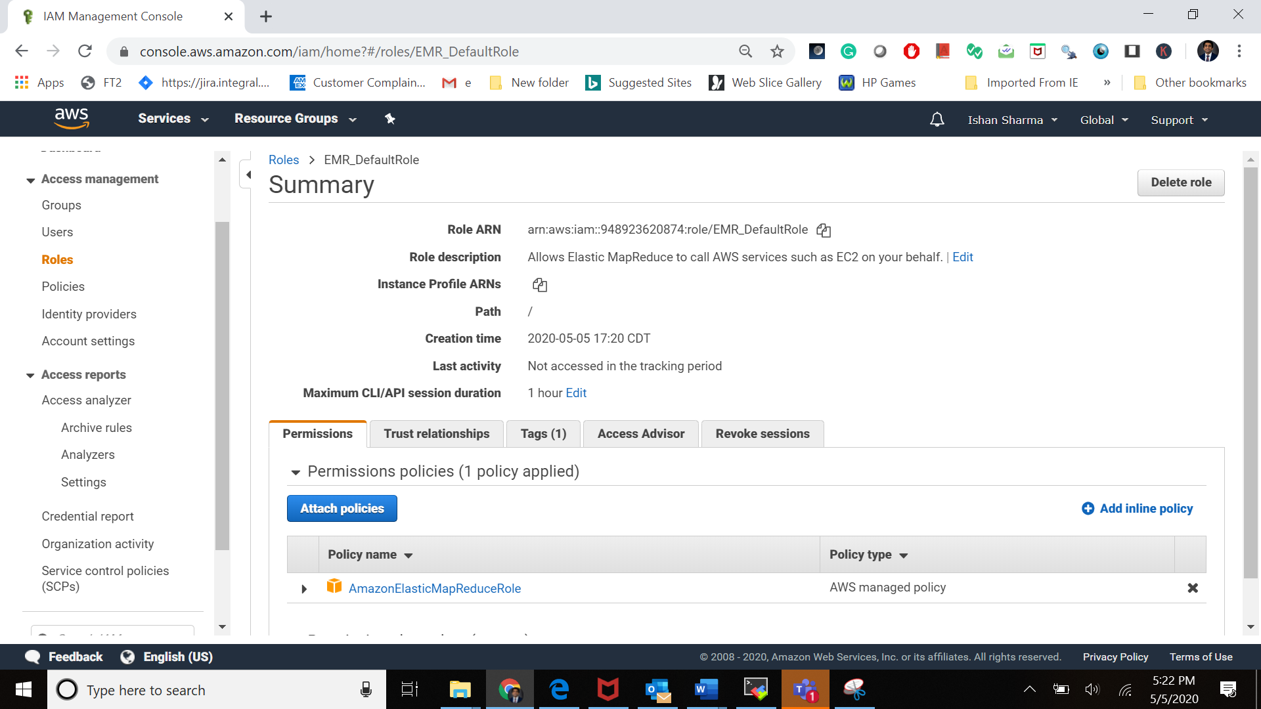

Click on the attach Policies:

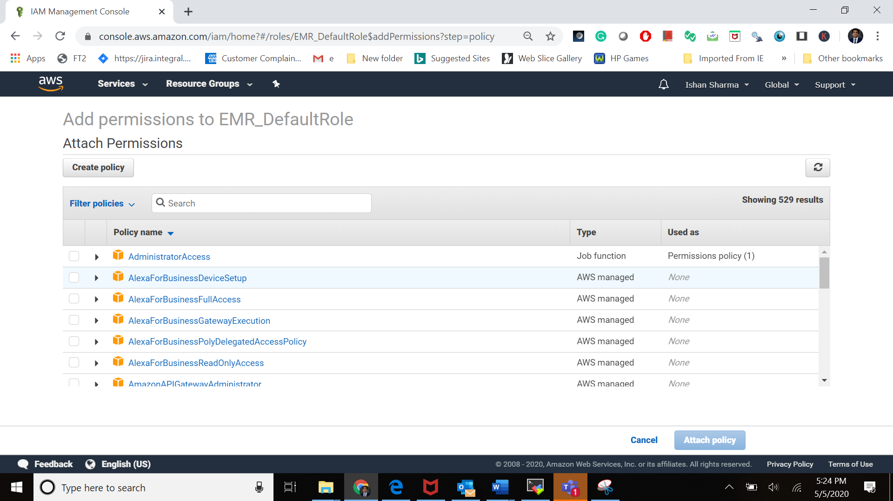

Here search the polices to be added in the role:AmazonElasticMapReduceFullAccess

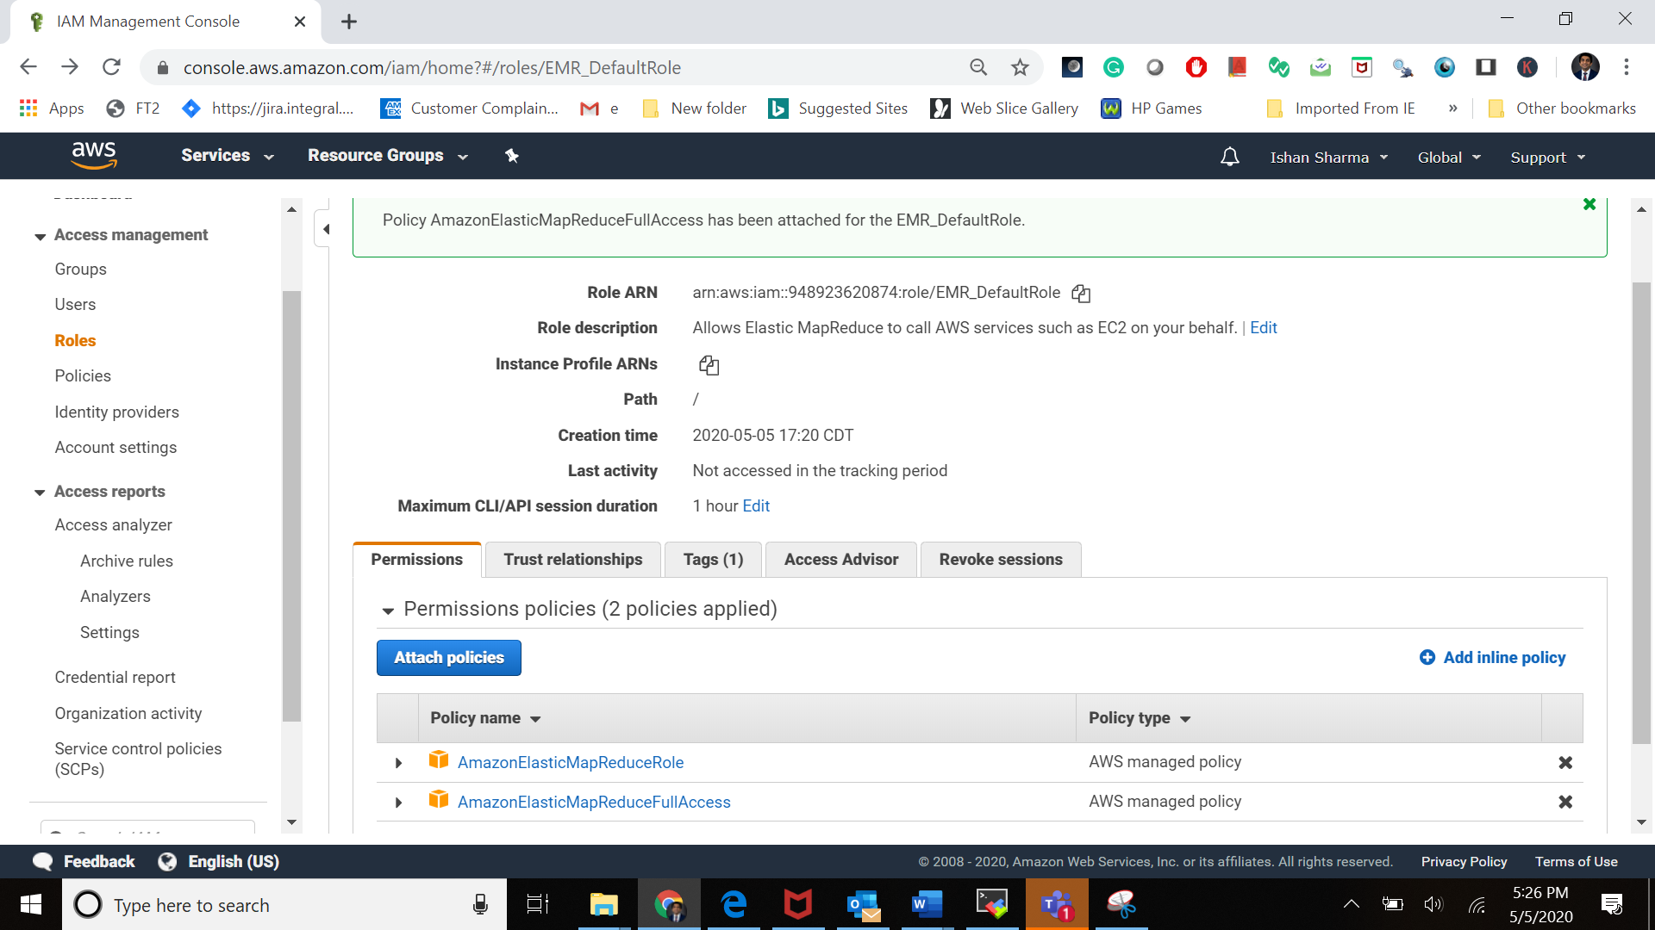

Now click on the attach policies again

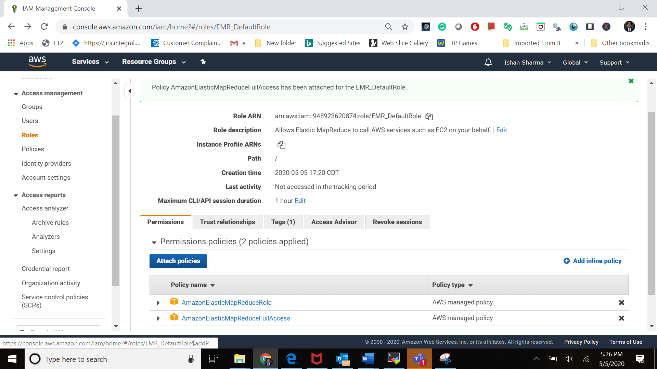

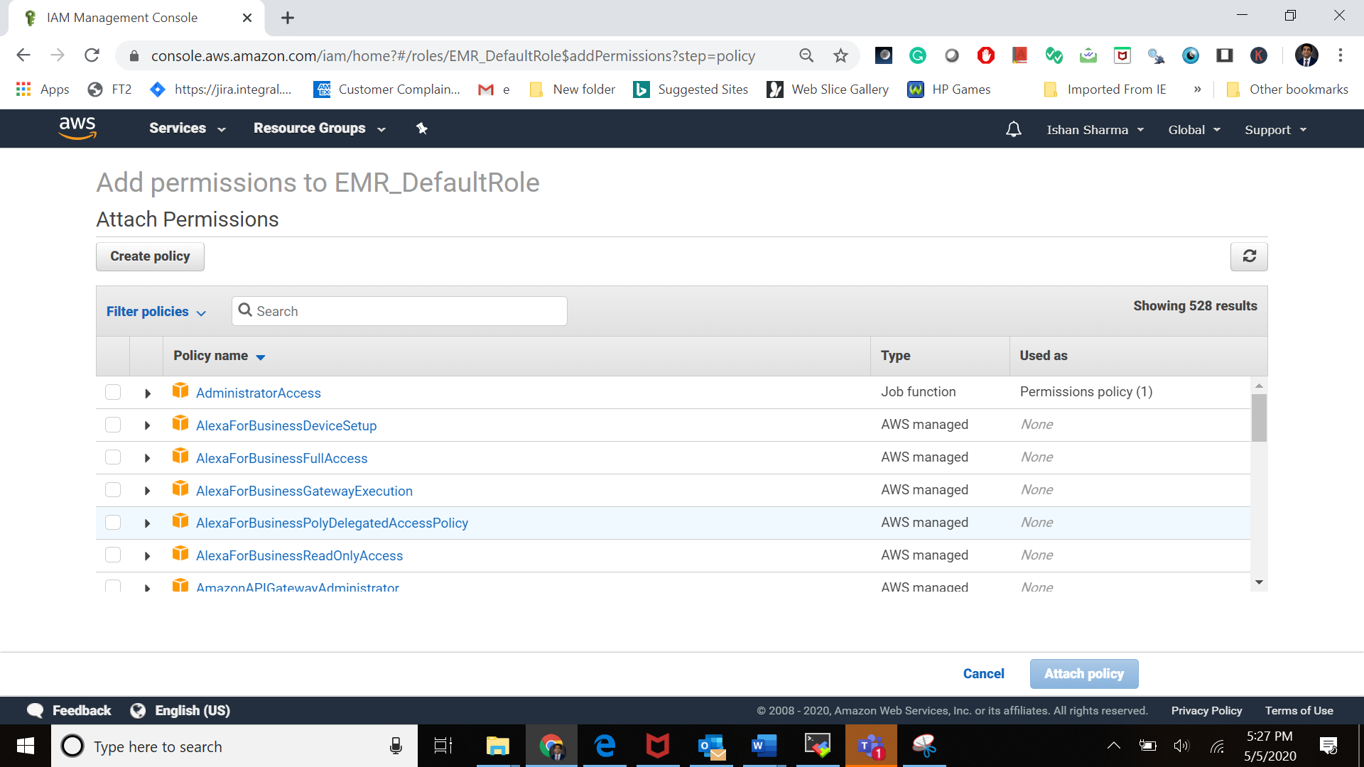

Search for the role AmazonElasticMapReduceforEC2Role

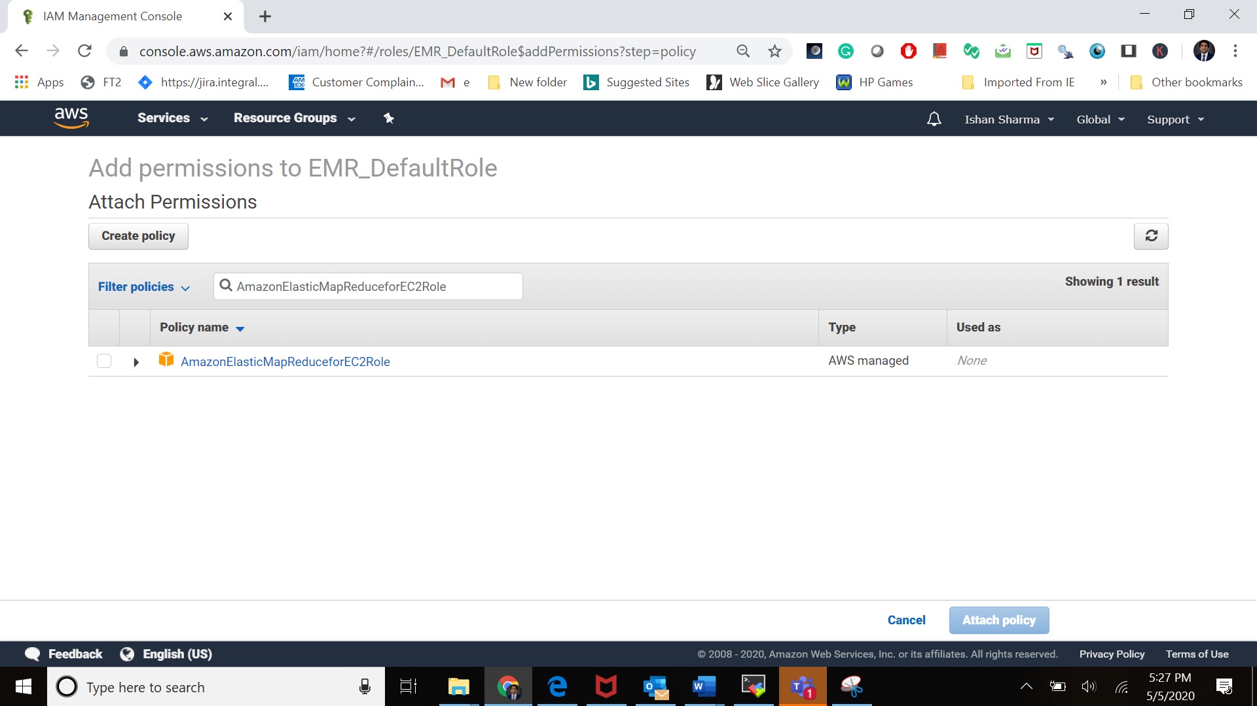

Select the polices and then click the attach policies button

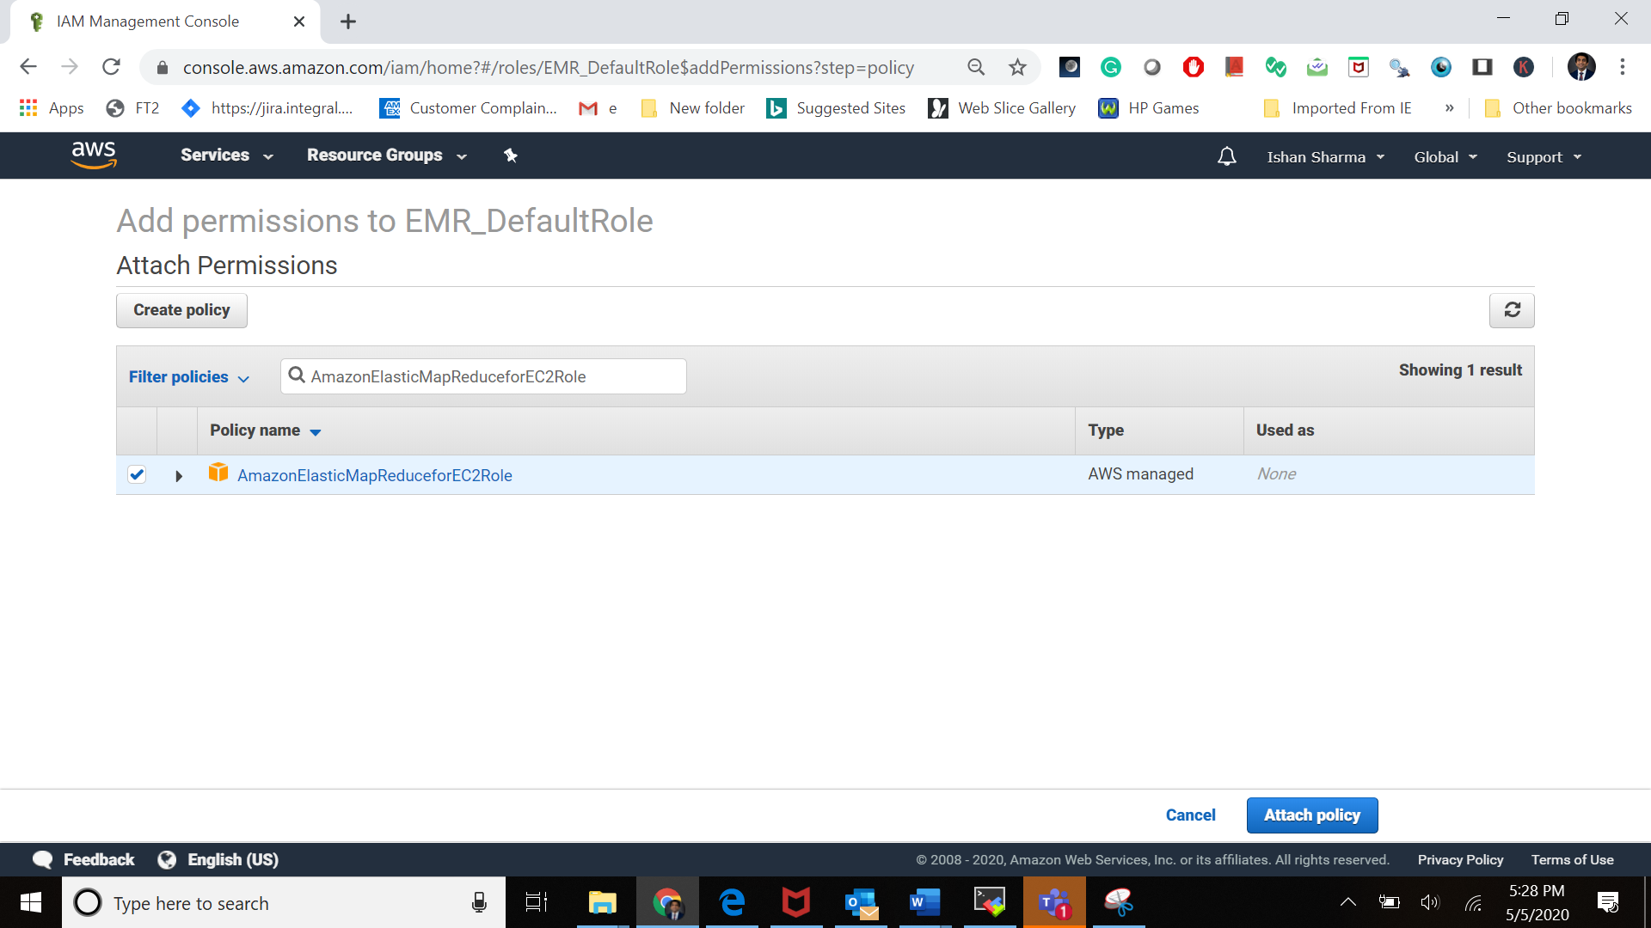

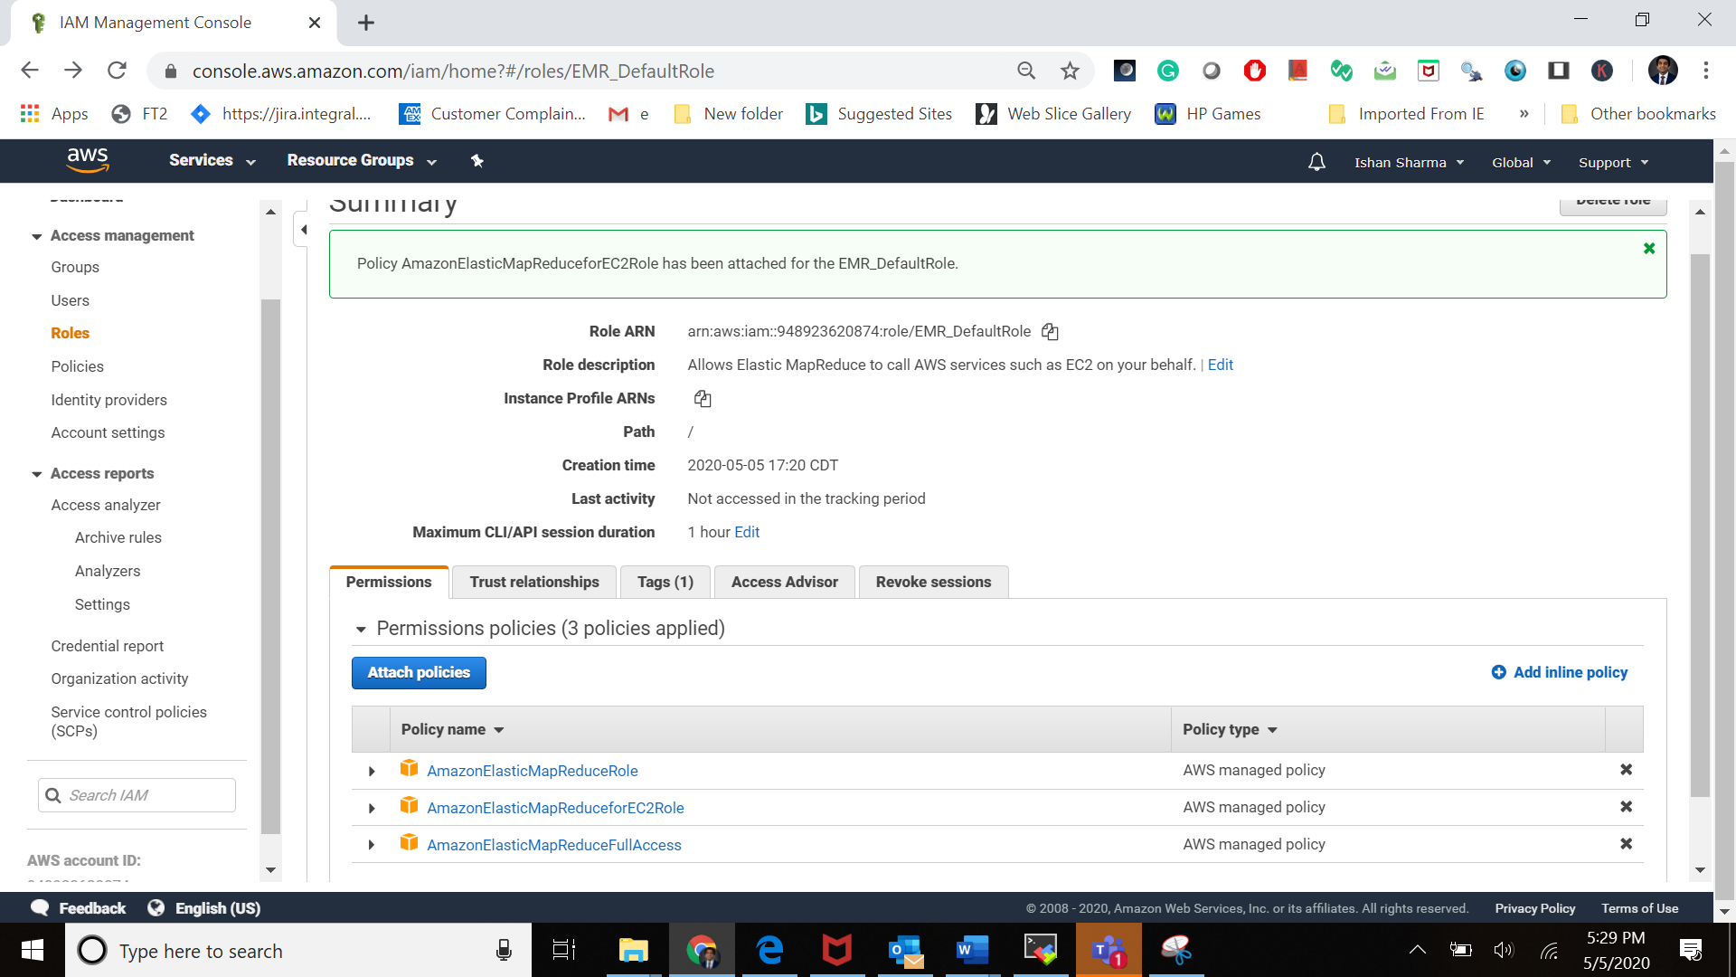

# Provision an EMR Cluster

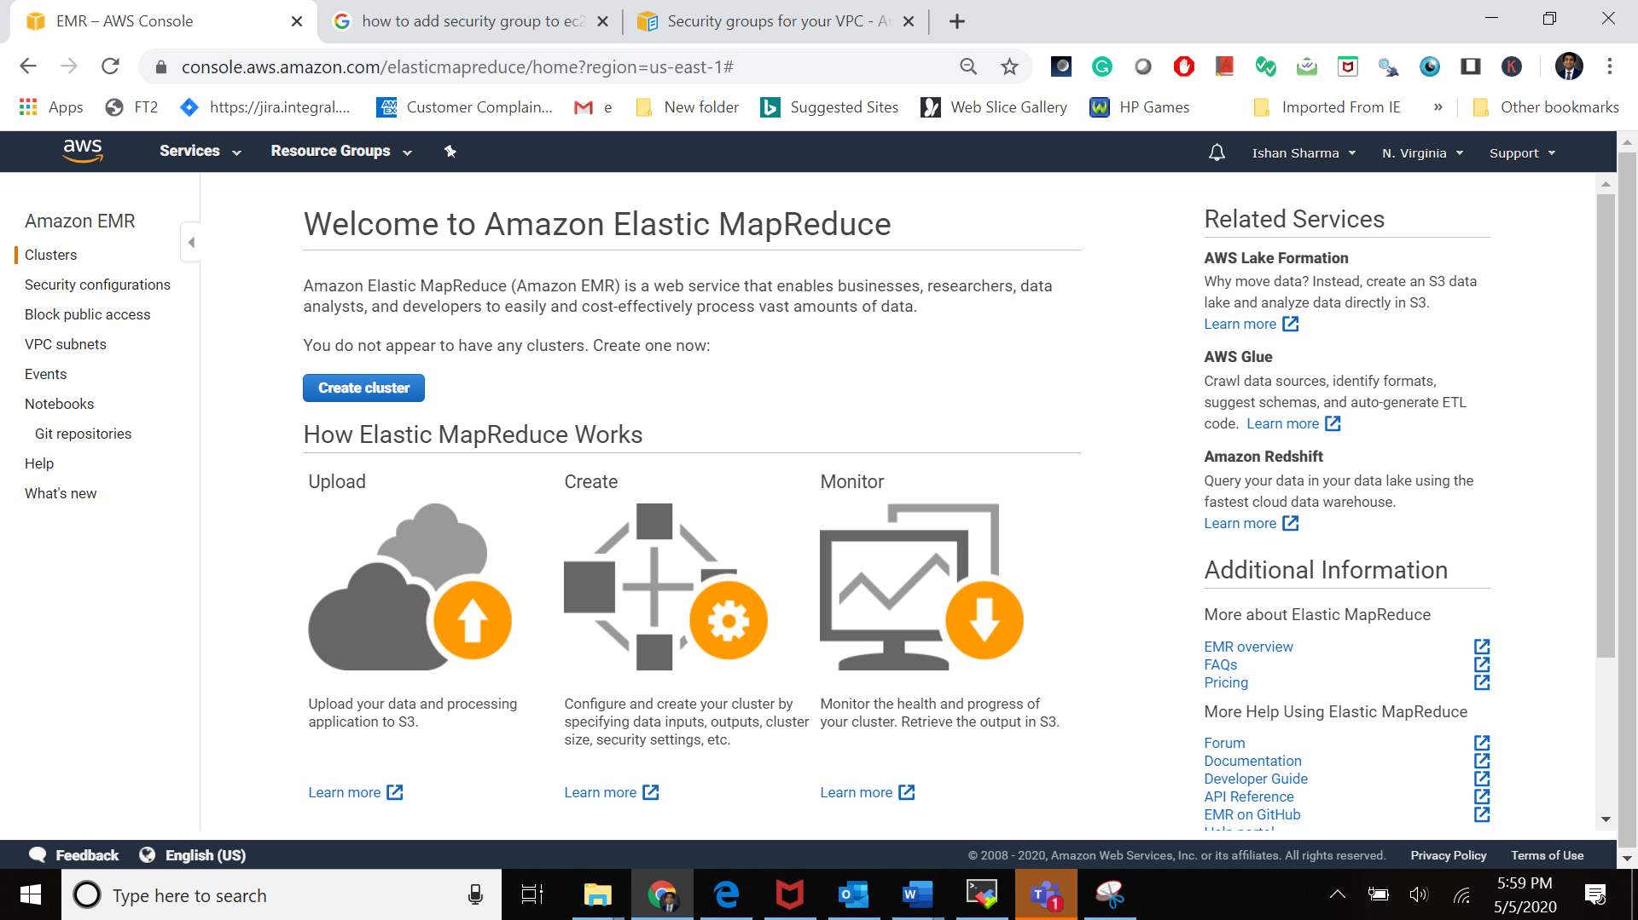

Click on the Create cluster

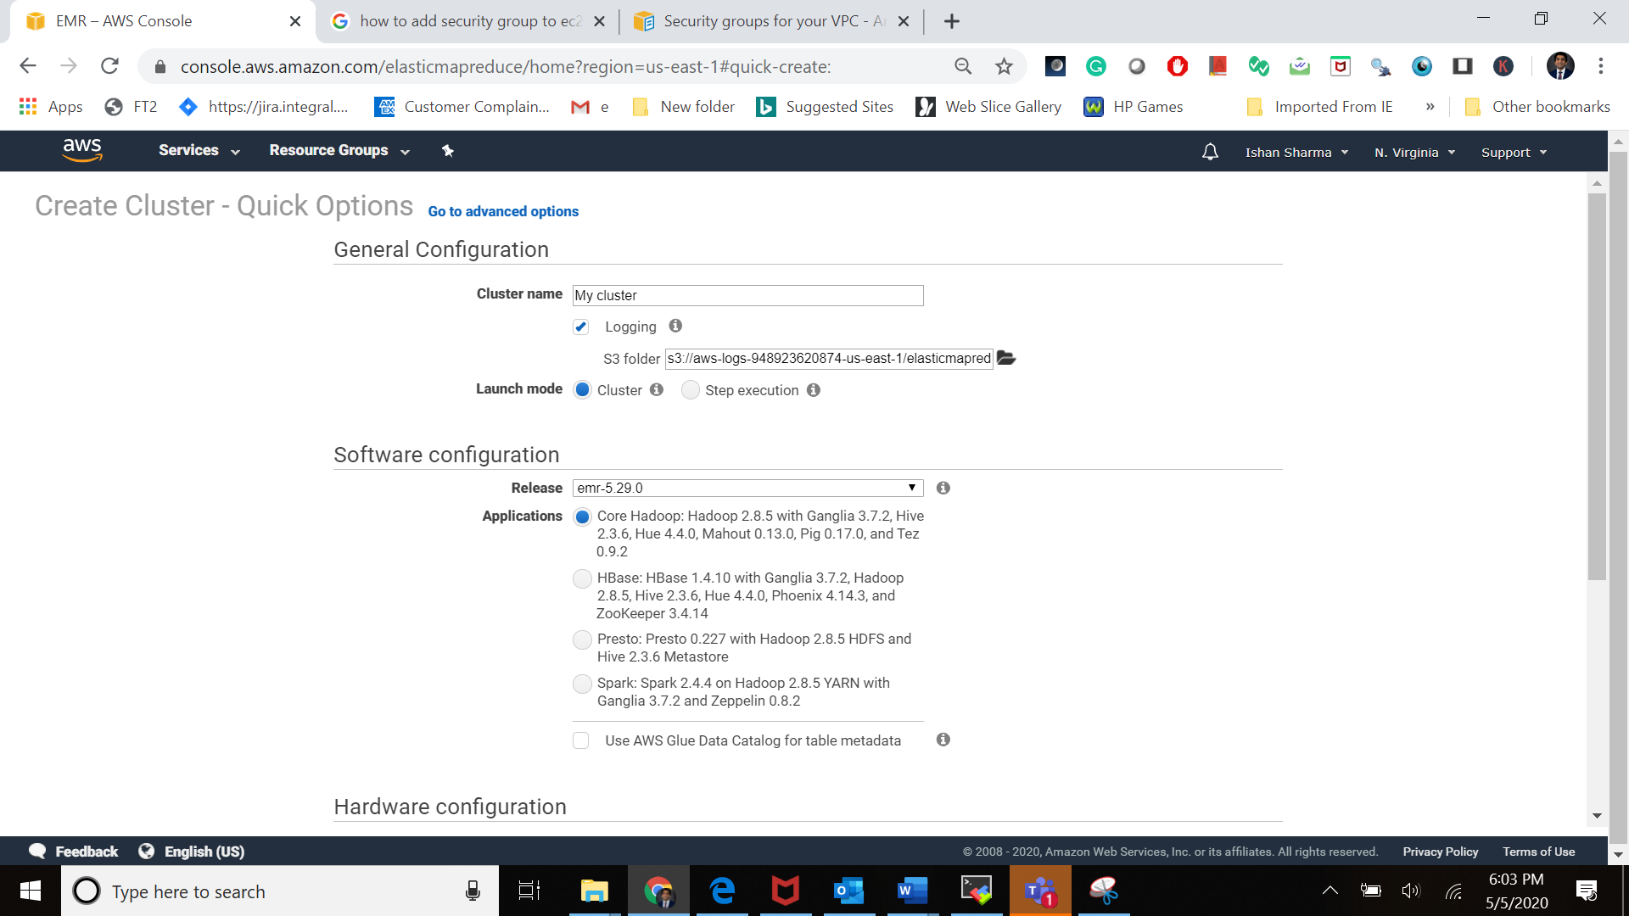

Here we are choosing the software bundle for our cluster based on Apache BigTop - "Bigtop is a project for the development of packaging and tests of the Hadoop ecosystem"

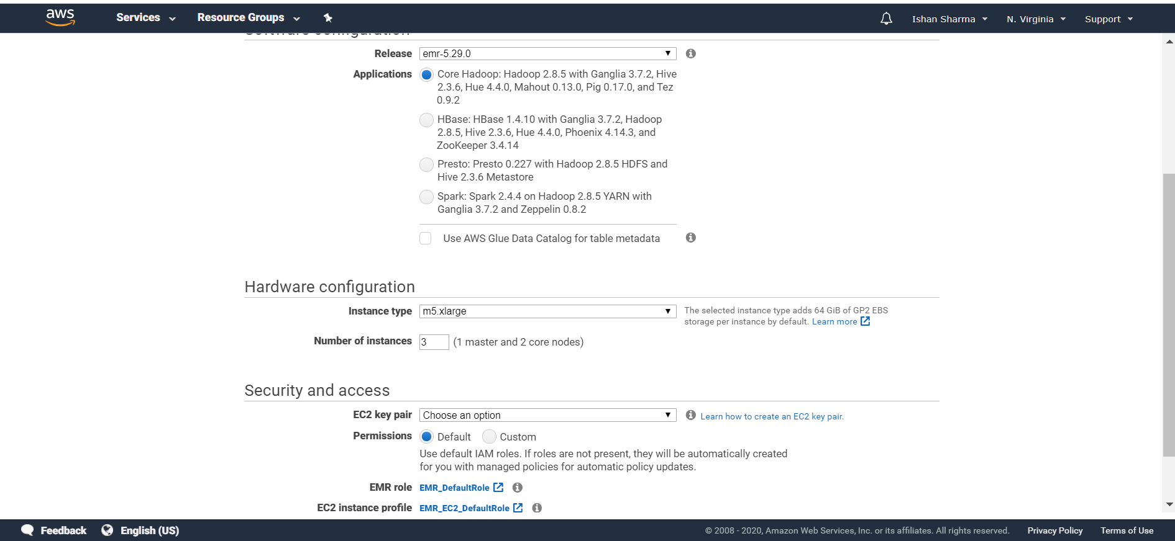

Click on the Go to advacne option select the following options:

Here we will be selecting the all the software component that one might need in their cluster.

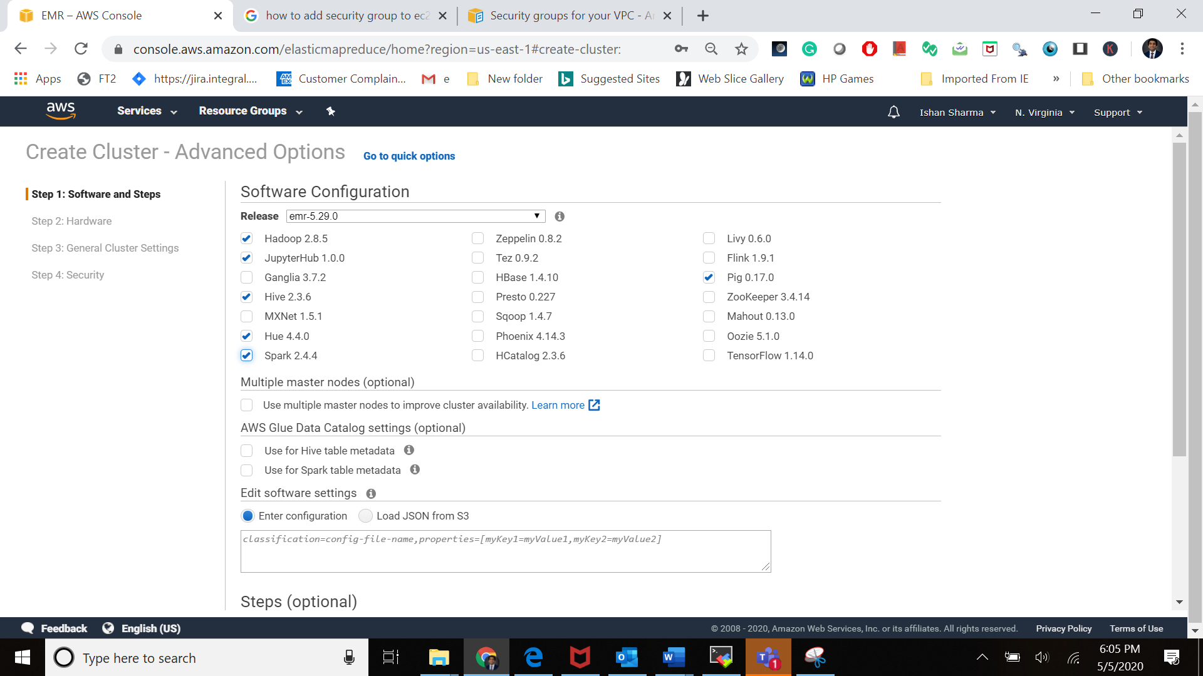

Keeping everything else as is.

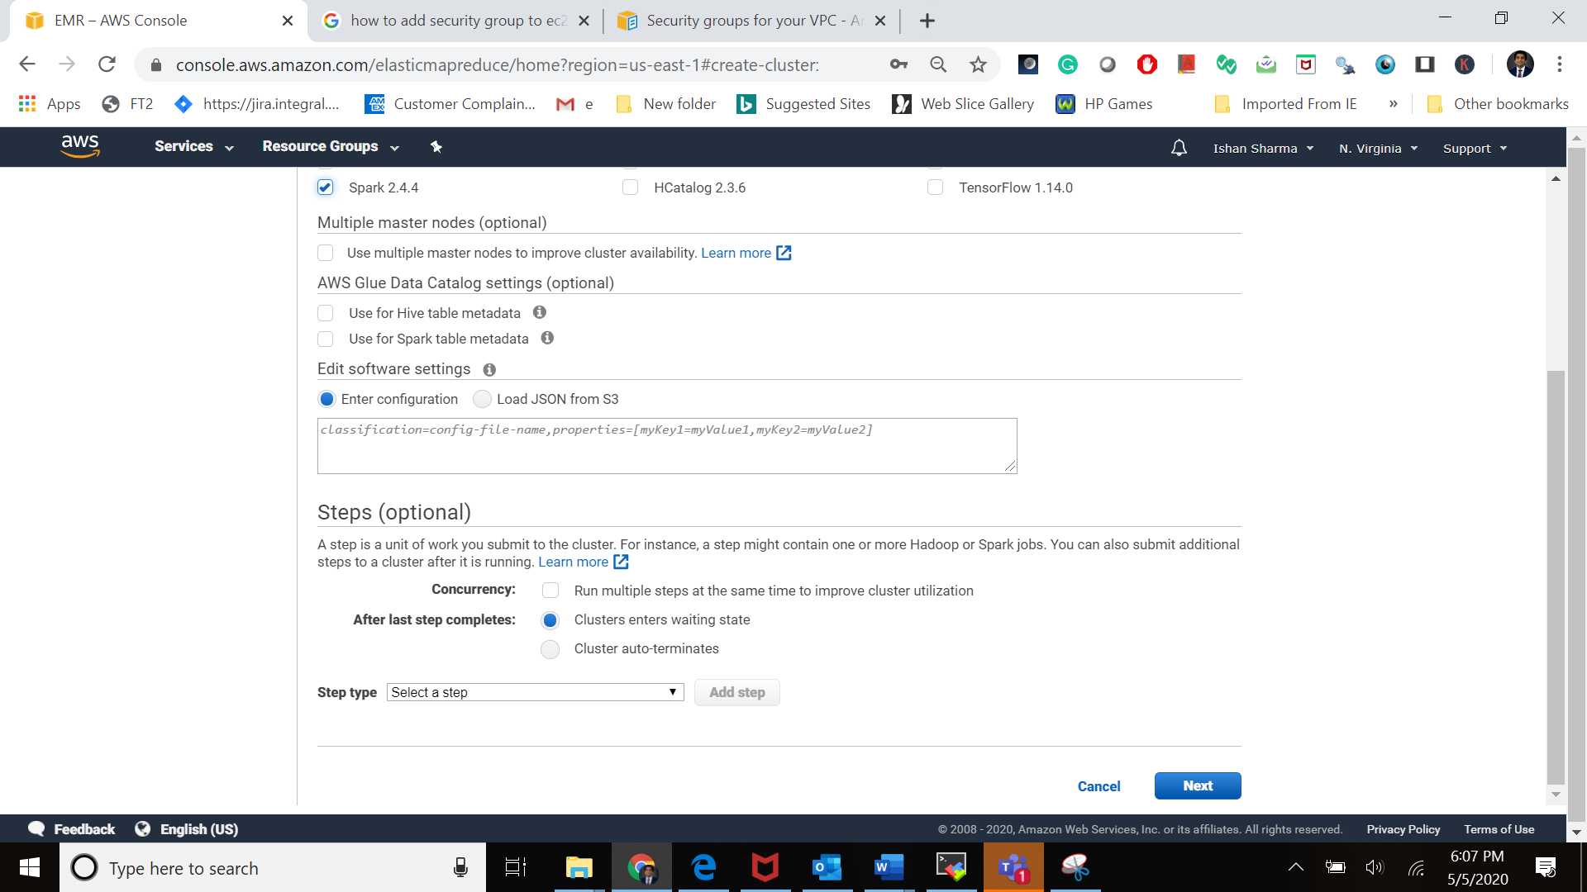

Click on the next

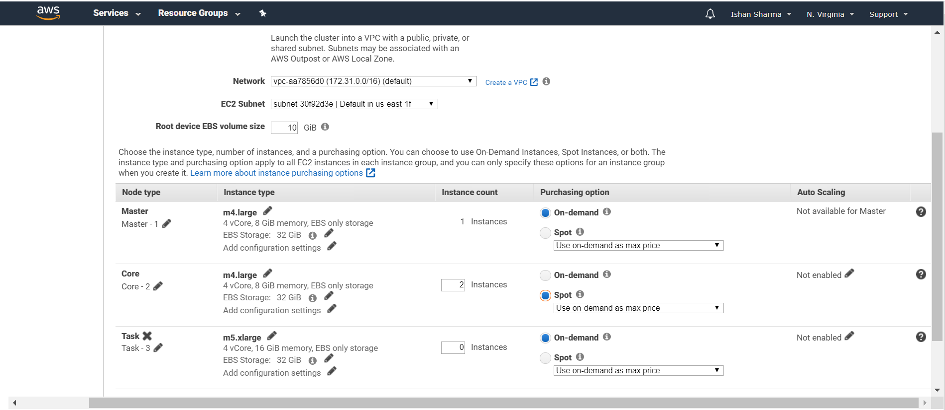

Select the highlighted item on this screen

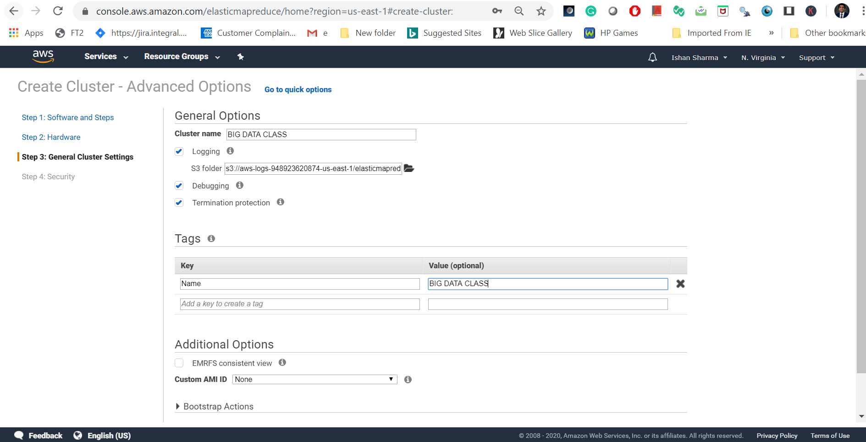

Add the tags here

Give the cluster name here

Now click the next button below

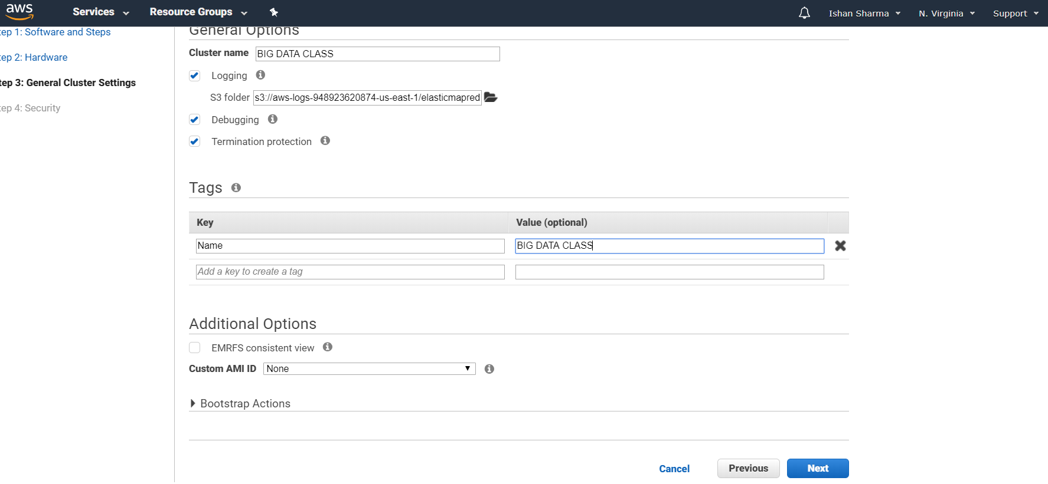

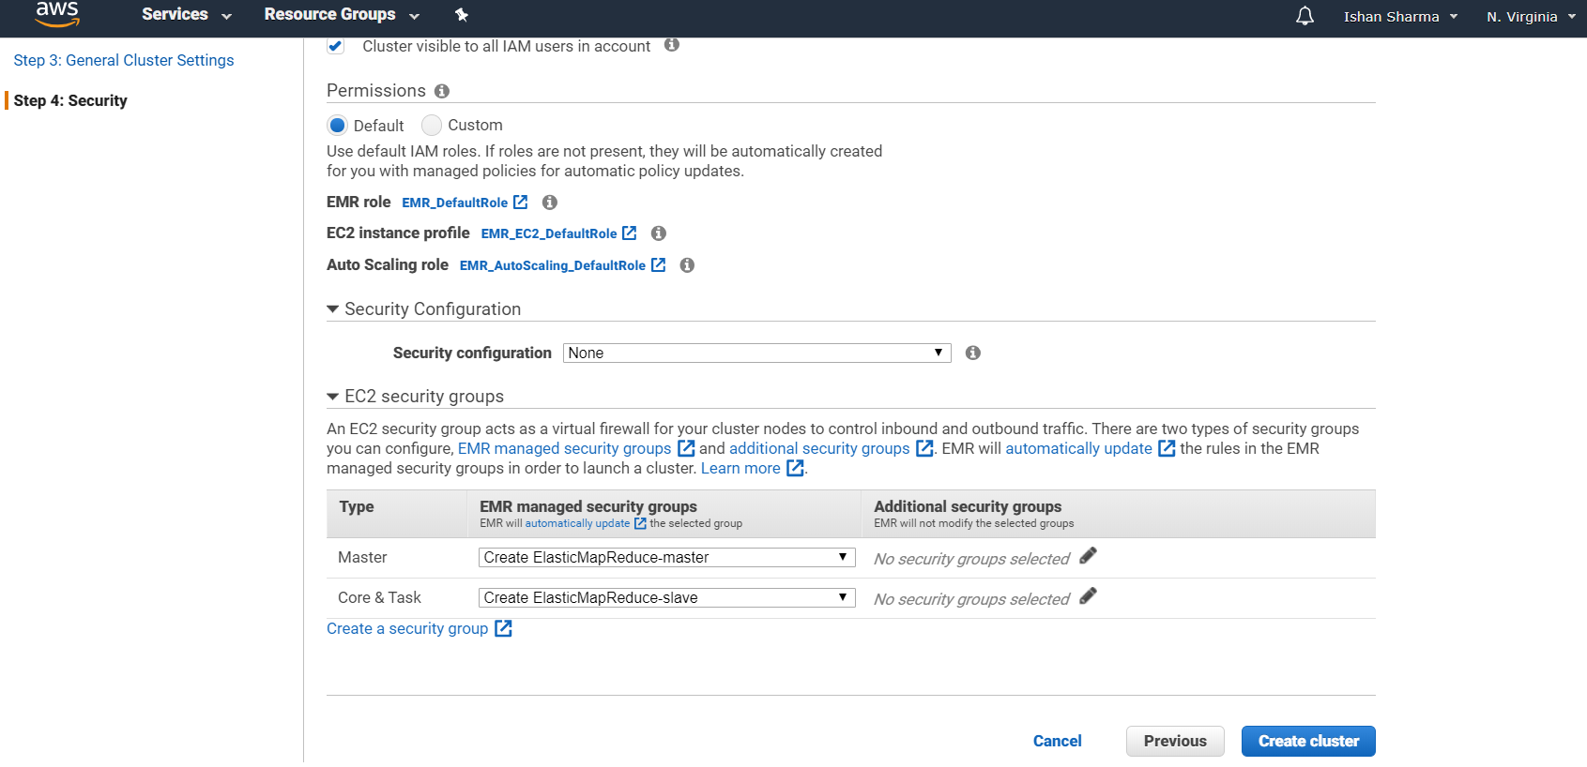

Go to the cluster dashboard

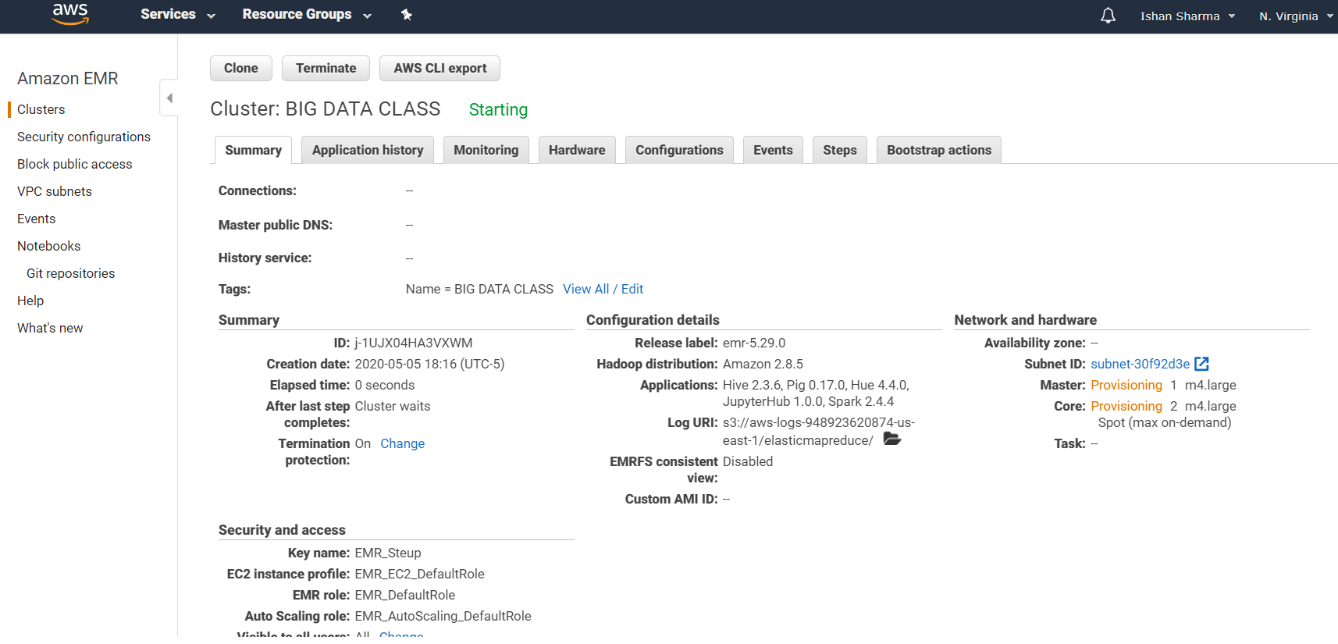

Even while the cluster is coming up go ahead and check your EC2 instance dashboard you will find the 3 nodes running.

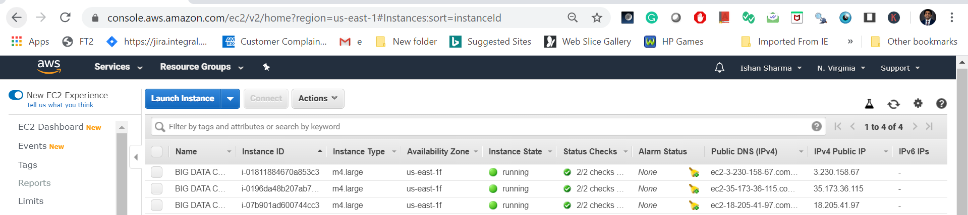

Now select the master node from the spawned nodes

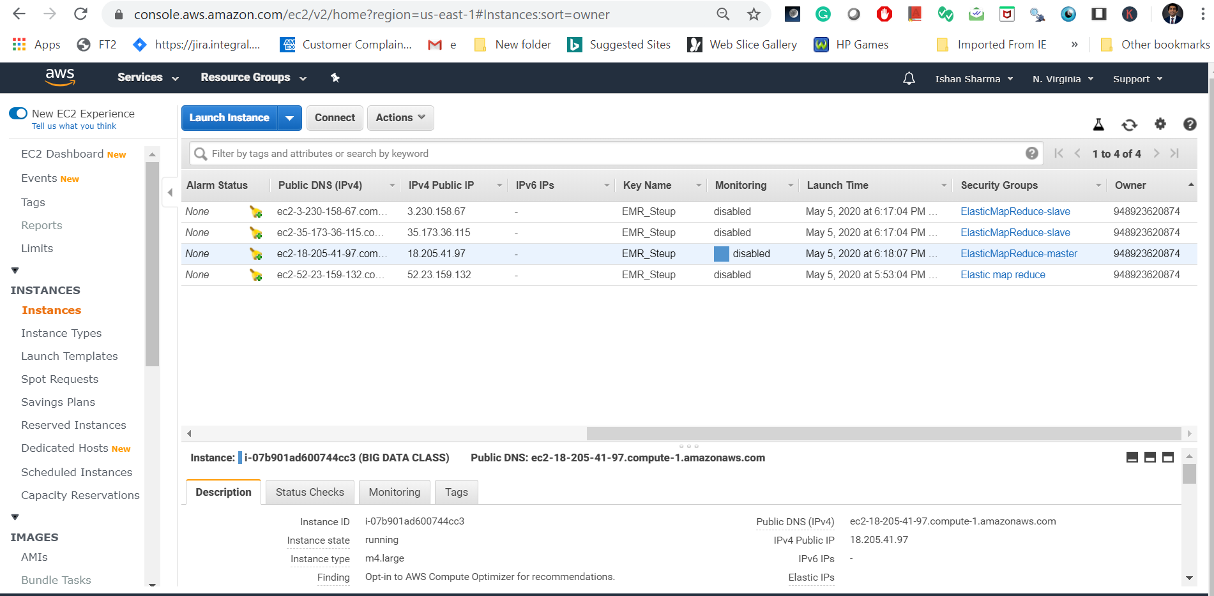

This is our master node of our cluster

Get/Copy its Public DNS (IPv4). In our example it is ec2-18-205-41-97.compute1.amazonaws.com

Now Modify the security group to allow the SSH access to the master node

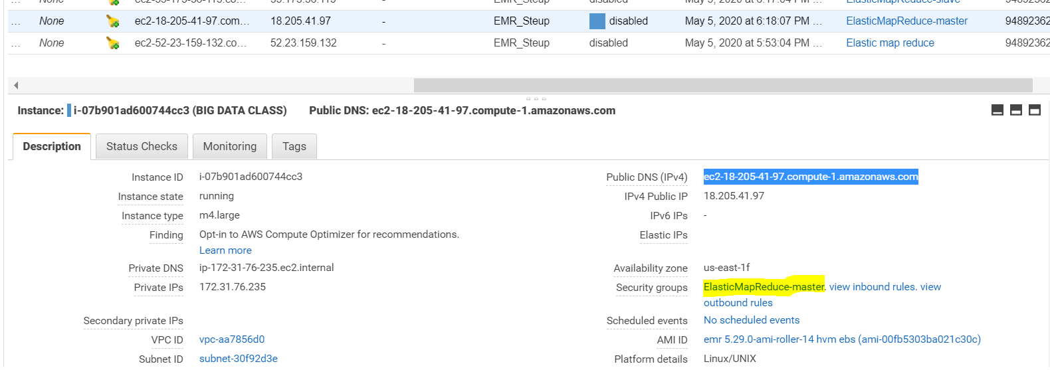

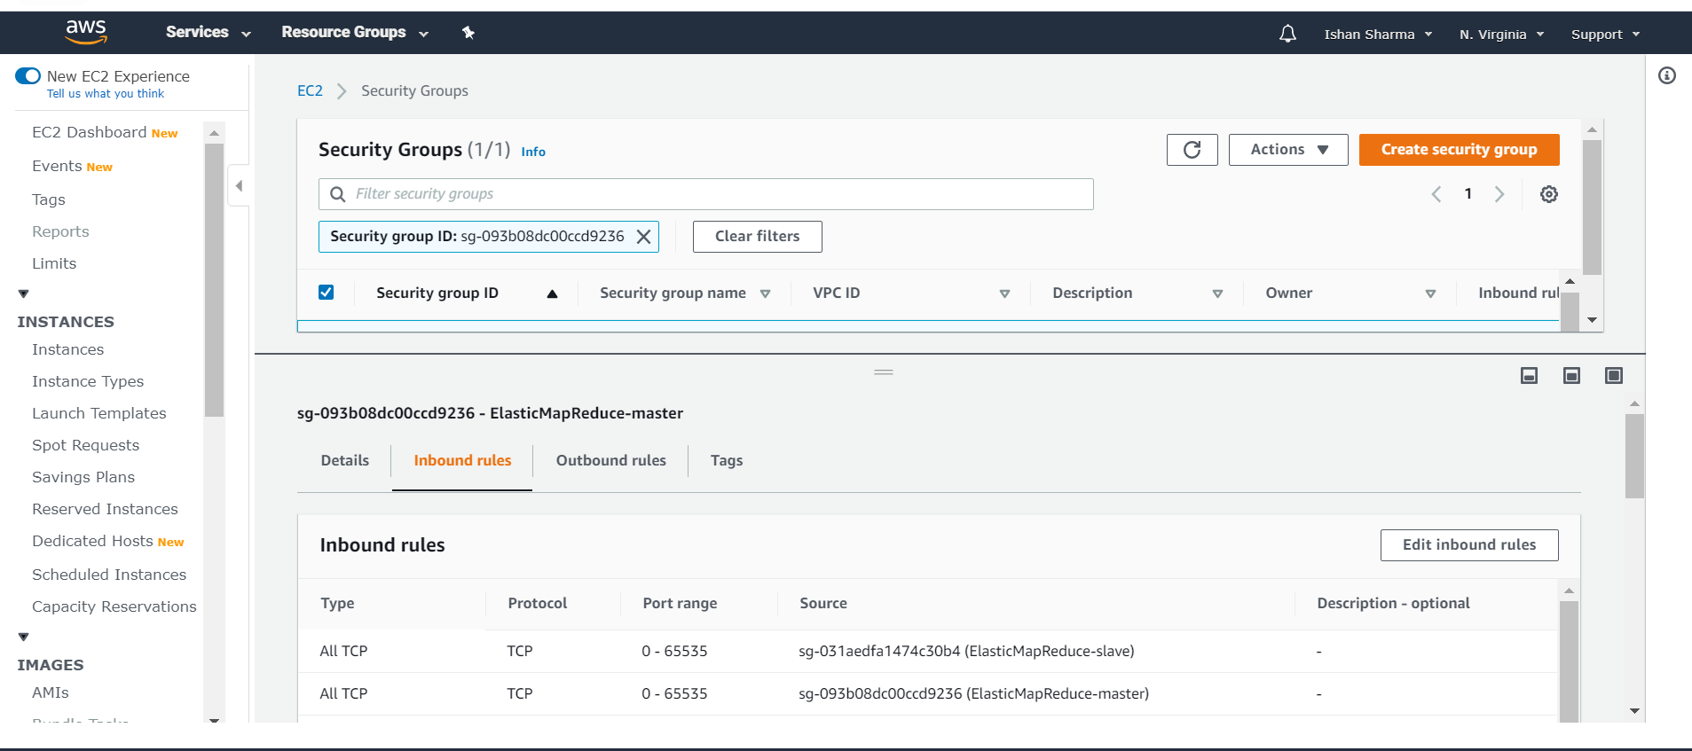

# Steps to modify the security group:

Click on the add rule and then type SSH

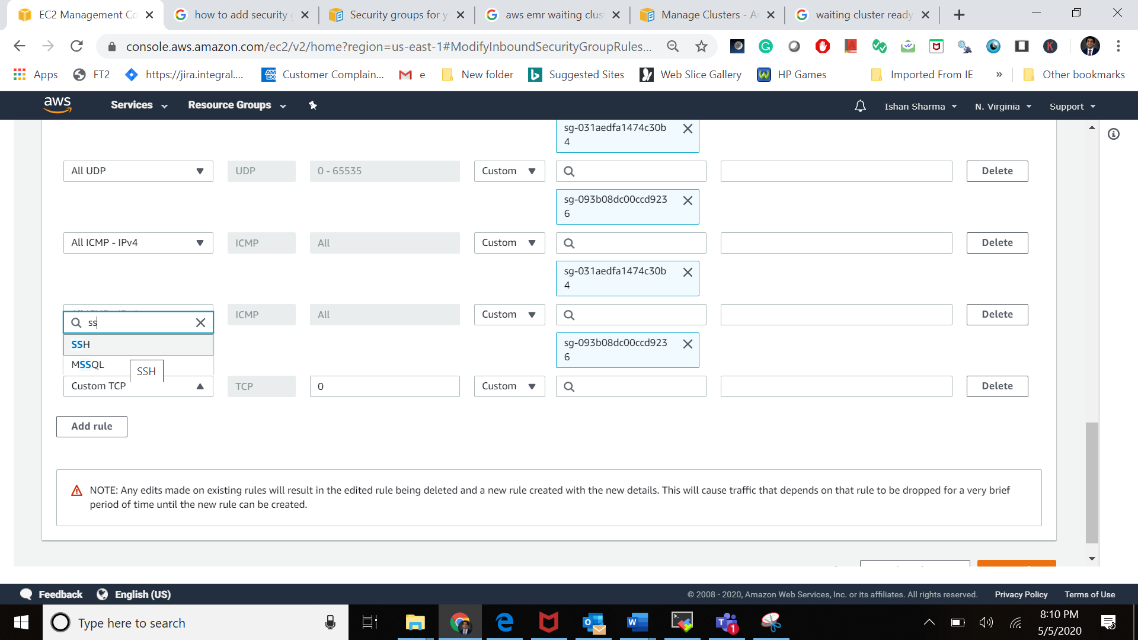

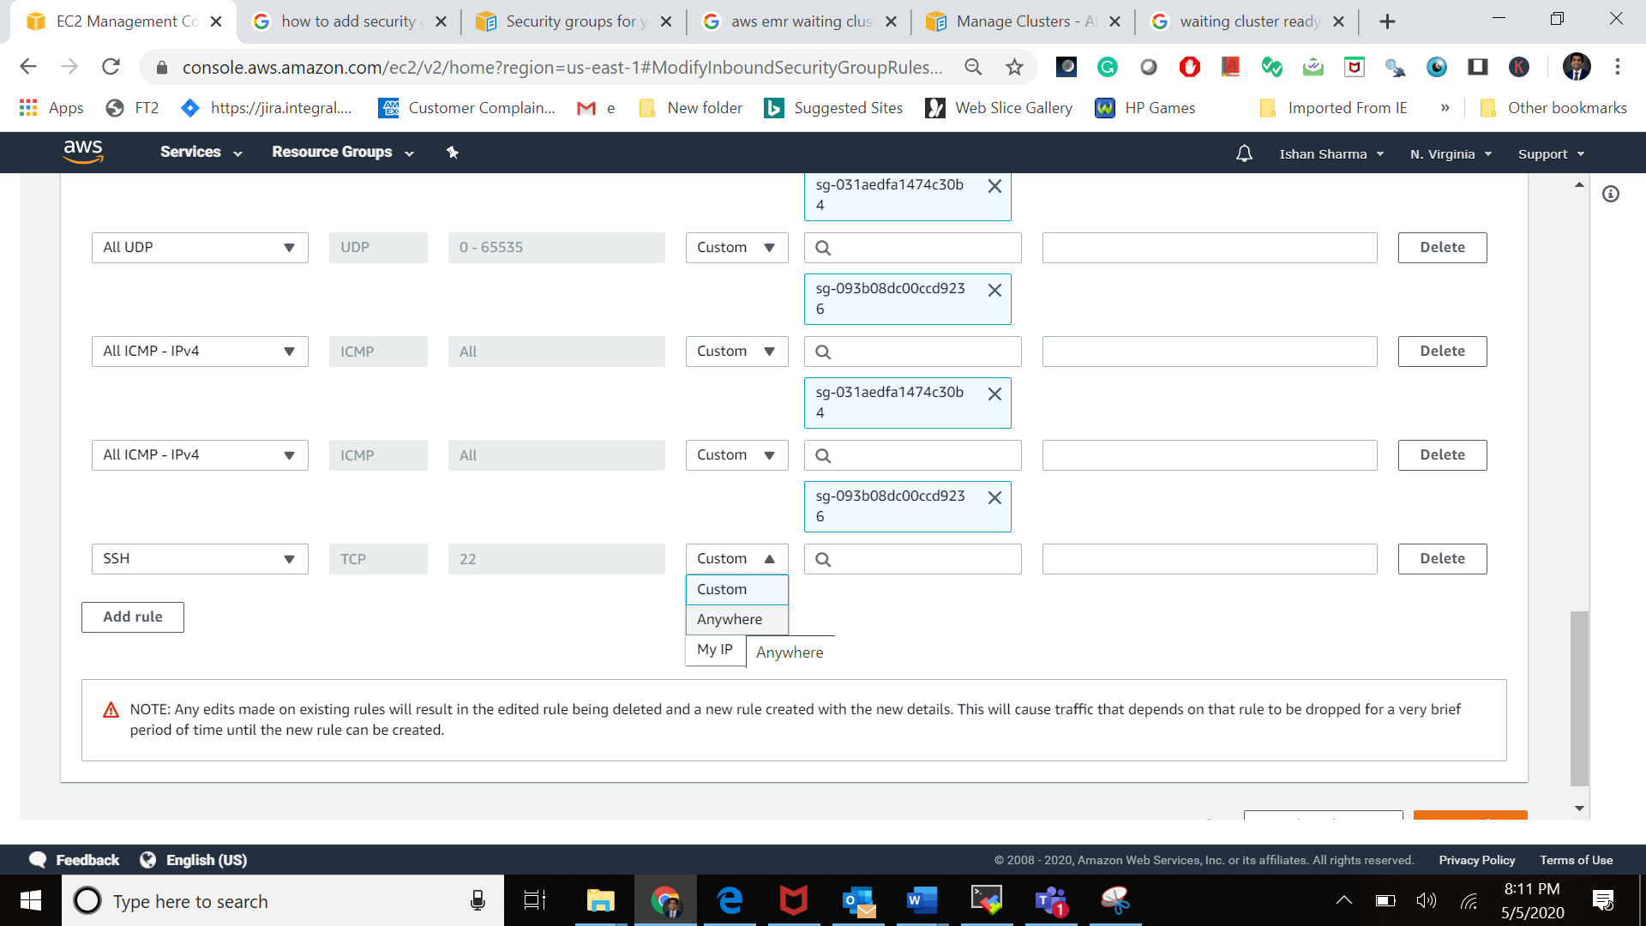

Click on save the rules

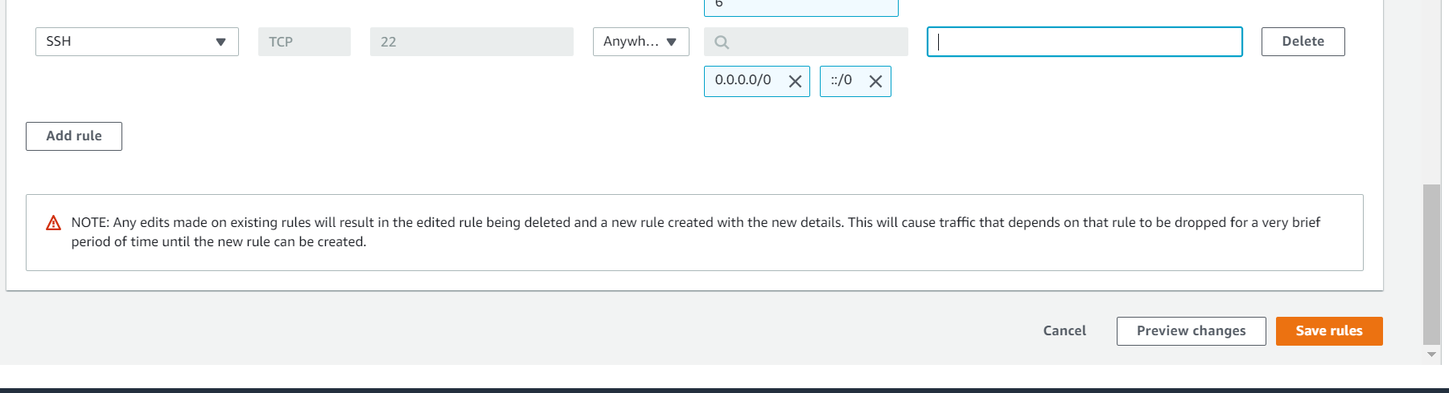

Security group modified

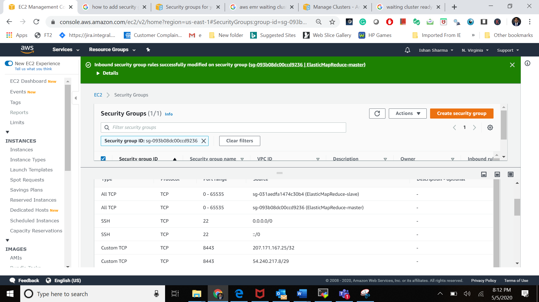

# Setup the terminal MobaXterm

Download the mobaxtern form the [here](https://mobaxterm.mobatek.net/download.html)

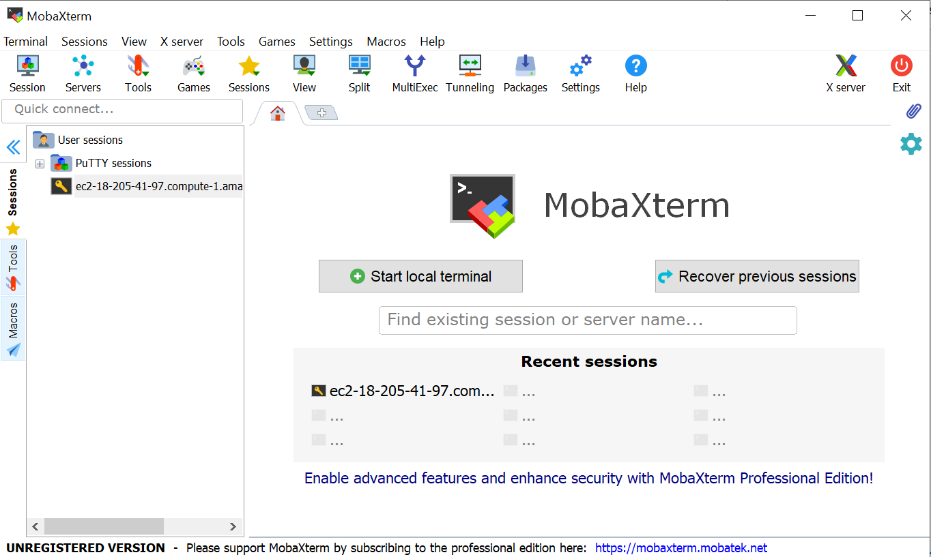

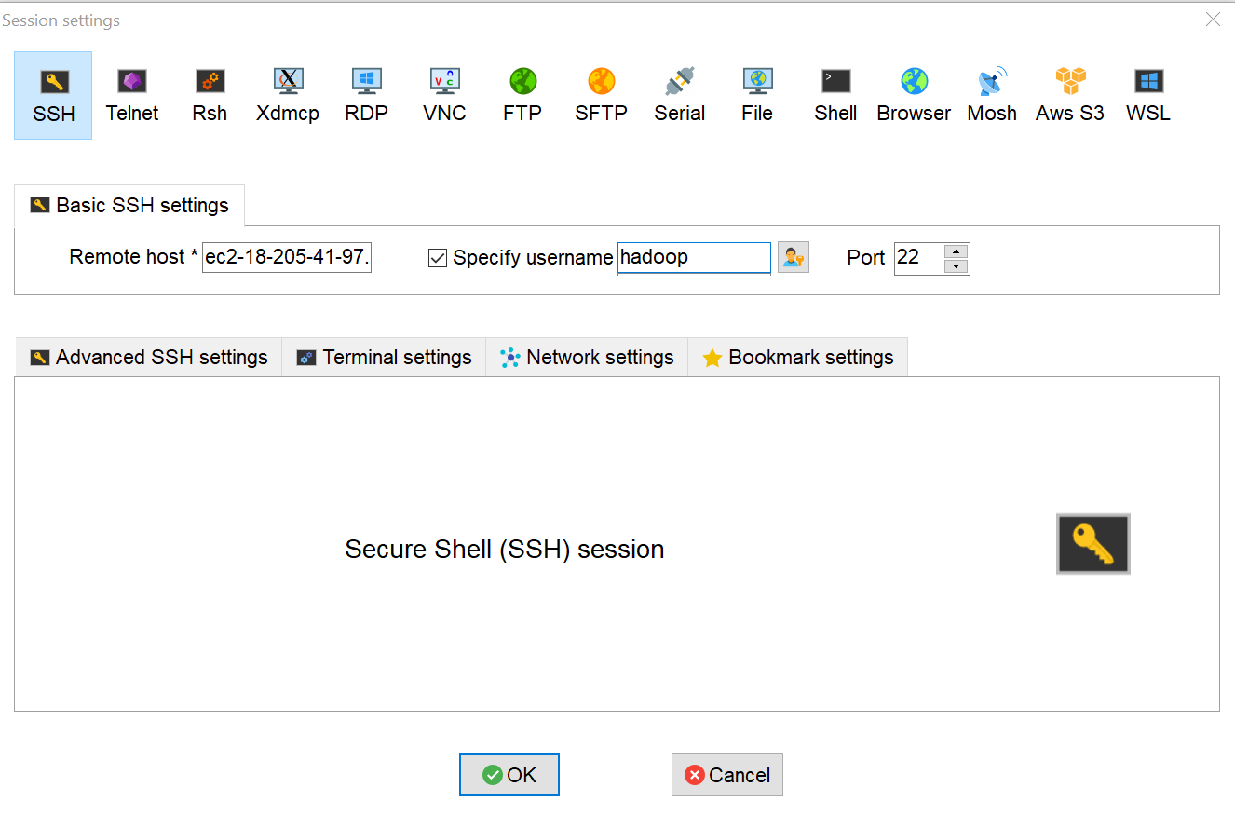

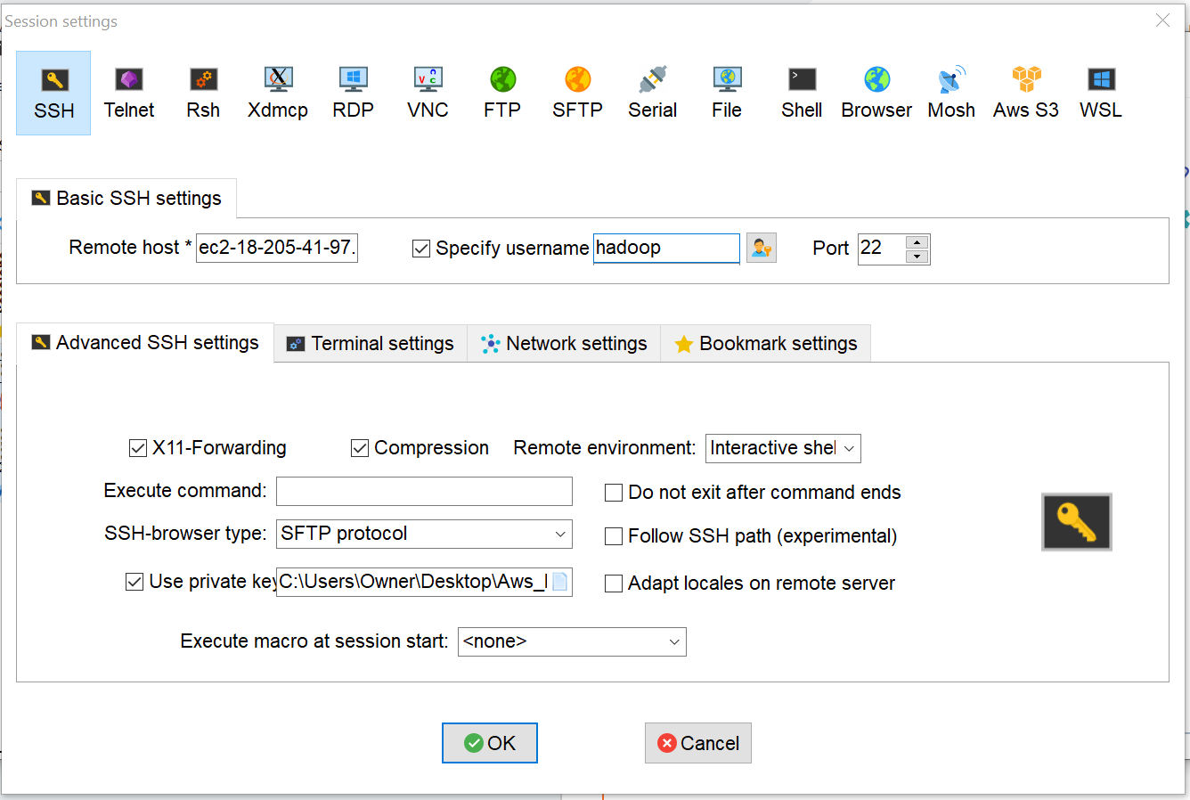

Click on Okay, if everything has been done correctly you should see the following screen.

You have connected with the EMR master node.

